 | Take Assessment - ESwitching Chapter 5 - CCNA Exploration: LAN Switching and Wireless (Version 4.0)
1 |  | Principio del formulario
  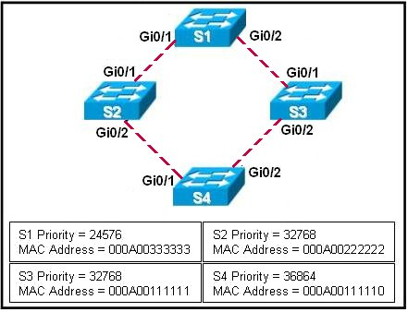
  Refer to the exhibit. The spanning-tree port priority of each interface is at the default setting. The network administrator enters the spanning-tree vlan 1 root primary command on S4. What is the effect of the command?
   | Spanning tree blocks Gi0/1 on S3.
   | Gi0/2 on S3 transitions to a root port.
   | Port priority makes Gi0/2 on S1 a root port.
   | S4 is already the root bridge, so there are no port changes.
2 |  | Principio del formulario
  Which two items are true regarding the spanning-tree portfast command? (Choose two.)
   | PortFast is Cisco proprietary.
   | PortFast can negatively effect DHCP services.
   | PortFast is used to more quickly prevent and eliminate bridging loops.
   | Enabling PortFast on trunks that connect to other switches improves convergence.
   | If an access port is configured with PortFast, it immediately transitions from a blocking to a forwarding state.

3 | Principio del formulario
  Which three statements are accurate regarding RSTP and STP? (Choose three.)
  RSTP uses a faster algorithm to determine root ports.
  RSTP introduced the extended system ID to allow for more than 4096 VLANs.
  Both RSTP and STP use the portfast command to allow ports to immediately transition to forwarding state.
  Like STP PortFast, an RSTP edge port that receives a BPDU loses its edge port status immediately and becomes a normal spanning-tree port.
  Configuration commands to establish primary and secondary root bridges are identical for STP and RSTP.
  Because of the format of the BPDU packet, RSTP is backward compatible with STP.
4 | Principio del formulario
  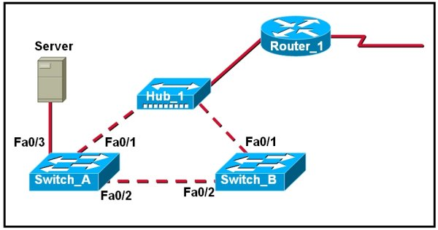
  Refer to the exhibit. Server sends an ARP request for the MAC address of its default gateway. If STP is not enabled, what will be the result of this ARP request?
  Router_1 will drop the broadcast and reply with the MAC address of the next hop router.
  Switch_A will reply with the MAC address of the Router_1 E0 interface.
  Switch_A and Switch_B will continuously flood the message onto the network.
  The message will cycle around the network until its TTL is exceeded.

5 | Principio del formulario
  Which statement or set of paired statements correctly compares STP with RSTP?
  STP and RSTP use the same BPDU format.
  STP specifies backup ports. RSTP has only root ports, alternate ports, and designated ports.
  STP port states are independent of port roles. RSTP ties together the port state and port role.
  STP waits for the network to converge before placing ports into forwarding state. RSTP places alternate ports into forwarding state immediately.
6 | Principio del formulario
  Which two criteria does a switch use to select the root bridge? (Choose two.)
  bridge priority
  switching speed
  number of ports
  base MAC address
  switch location
  memory size

7 | Principio del formulario
  How can a network administrator influence which STP switch becomes the root bridge?
  Configure all the interfaces on the switch as the static root ports.
  Change the BPDU to a lower value than that of the other switches in the network.
  Assign a lower IP address to the switch than that of the other switches in the network.
  Set the switch priority to a smaller value than that of the other switches in the network.
8 | Principio del formulario
  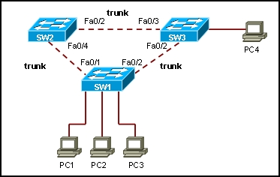
  Refer to the exhibit. All switches in the network have empty MAC tables. STP has been disabled on the switches in the network. How will a broadcast frame that is sent by host PC1 be handled on the network?
  Switch SW1 will block the broadcast and drop the frame.
  Switch SW1 will forward the broadcast out all switch ports, except the originating port. This will generate an endless loop in the network.
  Switch SW1 will forward the broadcast out all switch ports, except the originating port. All hosts in the network will replay with a unicast frame sent to host PC1.
  Switch SW1 will forward the traffic out all switch ports except the originating port as a unicast frame. All hosts in the network will replay with a unicast frame sent to switch SW1.

9 | Principio del formulario
  What three link types have been defined for Rapid Spanning-Tree Protocol? (Choose three.)
  shared
  end-to-end
  edge-type
  boundary-type
  point-to-many
  point-to-point
10 | Principio del formulario
  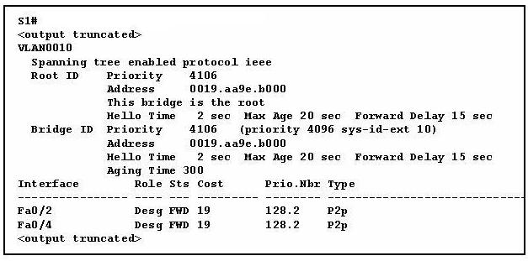
  Refer to the exhibit. What can be determined from the output shown?
  Two hosts communicating between ports Fa0/2 and Fa0/4 have a cost of 38.
  The priority was statically configured to identify the root.
  STP is disabled on this switch.
  The timers have been altered to reduce convergence time.

11 | Principio del formulario
  Which two actions does an RSTP edge port take if it receives a BPDU? (Choose two.)
  immediately loses its edge status
  inhibits the generation of a TCN
  goes immediately to a learning state
  disables itself
  becomes a normal spanning-tree port
12 | Principio del formulario
  When PVST+ was developed, the Bridge ID was modified to include which information?
  bridge priority
  MAC address
  protocol
  VLAN ID

13 | Principio del formulario
  What two elements will exist in a converged network with one spanning tree? (Choose two.)
  one root bridge per network
  all non-designated ports forwarding
  one root port per non-root bridge
  multiple designated ports per segment
  one designated port per network
14 | Principio del formulario
  In which STP state does a port record MAC addresses but not forward user data?
  blocking
  learning
  disabling
  listening
  forwarding

15 | Principio del formulario
  What two features of the Spanning-Tree Protocol contribute to the time it takes for a switched network to converge after a topology change occurs? (Choose two.)
  the max-age timer
  the spanning-tree hold down timer
  the forward delay
  the spanning-tree path cost
  the blocking delay
16 | Principio del formulario
  What Rapid Spanning Tree Protocol (RSTP) role is assigned to the forwarding port elected for every switched Ethernet LAN segment?
  alternate
  backup
  designated
  root
17 | Principio del formulario
  Which two statements are true about the default operation of STP in a Layer 2 switched environment that has redundant connections between switches? (Choose two.)
  The root switch is the switch with the highest speed ports.
  Decisions on which port to block when two ports have equal cost depend on the port priority and identity.
  All trunking ports are designated and not blocked.
  Root switches have all ports set as root ports.
  Non-root switches each have only one root port.

18 | Principio del formulario
  In which two ways is the information that is contained in BPDUs used by switches? (Choose two.)
  to negotiate a trunk between switches
  to set the duplex mode of a redundant link
  to identify the shortest path to the root bridge
  to prevent loops by sharing bridging tables between connected switches
  to determine which ports will forward frames as part of the spanning tree
19 | Principio del formulario
  Which two statements describe the BIDs used in a spanning tree topology? (Choose two.)
  They are sent out by the root bridge only after the inferior BPDUs are sent.
  They consist of a bridge priority and MAC address.
  Only the root bridge will send out a BID.
  They are used by the switches in a spanning tree topology to elect the root bridge.
  The switch with the fastest processor will have the lowest BID.

20 | Principio del formulario
  What is the first step in the process of convergence in a spanning tree topology?
  election of the root bridge
  blocking of the non-designated ports
  selection of the designated trunk port
  determination of the designated port for each segment

